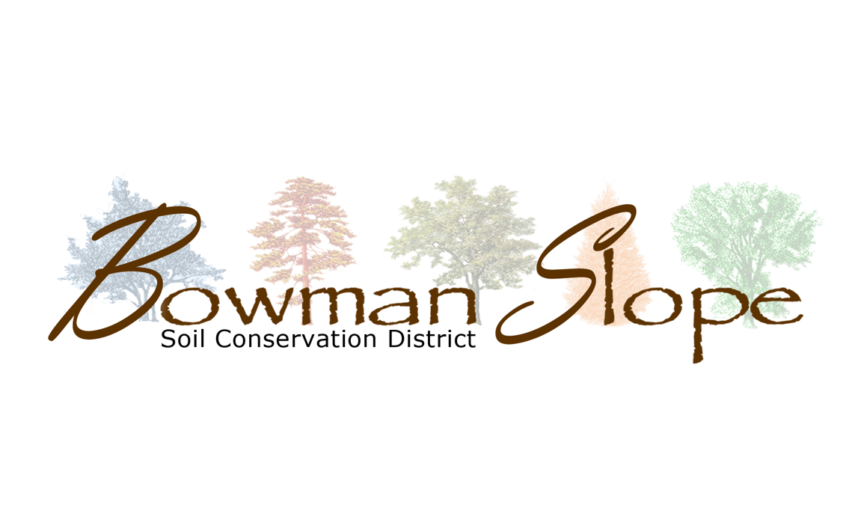

**Policy Manual**

**Bowman-Slope Soil Conservation District**

**Personnel Policy for**

**Permanent Employee Positions**

***Compensation & Benefits***

Salary: Determined by SCD Board per position

Insurance & Retirement: Determined by SCD Board per position

Payday is the 1st and 16th day of the month or the 1st working day after the 1st or 16th.

Performance evaluations will be conducted yearly, at the December Board Meeting, at which time salary negotiations may be entered into.

There is a Six-Month Probationary Period for new SCD Hires.

Normal working hours are: Monday thru Friday, 8:00 am to 4:30 pm.

Time & Leave will be charged in increments of 15 minutes.

Employee timesheets need to be signed by the employee certifying accuracy and then checked and signed by one additional office personnel.

***Breaks:***

Coffee Breaks - 15 minutes am

15 minutes pm

Lunch – 30 minutes (not paid)

***Leave:***

**Annual Leave** (Vacation) earned is paid leave, earned at a rate of:

Years of Service Hours earned/per hours worked

0 thru 3 1hr/20 hrs.

4 thru 14 1.5 hrs/20 hrs.

15 and over 2 hrs/20 hrs

*Only a balance of 240 hours of Annual Leave maybe carried over from one year to the next. Accrued Annual Leave is paid when employment terminates.

**Sick Leave** is approved absence from work (with pay) granted when an employee is unable to work, or to provide care for a family member, due to illness, injury, pregnancy/birth, or is undergoing medical, dental or optical examination or treatment. Accrued sick leave may be carried over from one year to the next. Accrued sick leave is not paid when employment terminates unless determined by the board.

Sick Leave is earned at a rate of: 1 hour per 20 hours worked.

***Overtime & Credit Time:***

The SCD Employees are eligible for overtime compensation for seasonal work (tree planting and fabric installation). Outside of seasonal work, the Credit Leave Policy applies.

Credit hours can be earned without pre-approval for those hours worked in excess of the basic work requirements to complete pending workload items. Employees may not carry more than 24 hours from one pay period to another.

Credit hours maybe earned in increments of 15 minutes. Credit leave must be used before employee may be granted annual leave, provided it will not result in the employee forfeiting accrued annual leave. Once an employee has taken credit leave, he or she may not request overtime pay for the work.

* Employee time sheets will be kept on file for 3 years, Supervisors will randomly review employee time sheets.

***Meeting Reimbursement***

Employees are reimbursed at ND State per diem and for hours spent traveling and in attendance to approved SCD business. A maximum of 6 credit leave hours can be earned per day. SCD Supervisor approval is required for to earn over 6 hours of credit leave in one working day.

\***The Bowman-Slope SCD will follow and will be updated with the USDA’s Natural Resources Conservation Service, General Manual, Title 360 policies regarding:**

* Military Leave
  + Absence with full pay for certain types of active duty, active training, and inactive duty training.
* Family Leave
  + Follow the Family Medical Leave Act
* Administrative
  + Excused/authorized absence without loss of pay and without charge to leave
* Holiday Leave Including
  + New Years Day, Marin Luther King’s Birthday, President’s Day, Memorial Day, Independence Day, Labor Day, Columbus Day, Veterans Day, Thanksgiving Day and the Friday after Thanksgiving Day, Christmas Day.
* Blood Donation
  + An employee making a donation of blood, for which there will not be compensation, may be excused from work without charge to leave for a period not to exceed four hours for the purpose of subsequent rest and recuperation.
* On-the-job Injury
* Hazardous Weather
  + Closure of the SCD office will follow the Bowman County Courthouse’s declaration. Employees are considered on call during an office closure due to the weather and will be paid for a regular 8-hour day and not forced to use leave.
* Funeral Leave
* Court Leave
  + Authorized absence of work, without charge to leave or loss of pay, can be granted for jury duty or for attending proceedings in a nonofficial capacity as a witness on behalf of either party, as long as one of the parties is a Federal, State, or Local government.
* Registration and Voting Leave
  + In locations where the polls are not open at least three hours before or after and employee’s regular work hours, a limited amount of excused absence may be granted to permit the employee to vote.
* Leave With-Out Pay
  + An SCD Employee’s request for Leave With-Out Pay needs to be made to the Soil Conservation District Board.

***Transportation***

The SCD will provide a vehicle for official business. The SCD will provide compensation, at the ND State mileage rate, when a personal vehicle is used for official business, upon SCD supervisor approval.

***Seasonal Employees***

Seasonal employees’ complete duties as assigned by SCD Technician and/or SCD Manager. Salaries are approved by SCD Board.

***Position Job Description***

See attached job descriptions for the positions of:

* District Clerk
* District Manager
* District Technician
* Watershed Coordinator

**Bowman-Slope Soil Conservation District**

**Supervisor Policy**

***Compensation***

* $62.50 plus mileage and per diem (at the ND State rate) per meeting and/or event in the performance of their official duties as a supervisor.
* Supervisors will be paid for their compensation monthly with a voucher, requiring that Supervisor’s signature and approval.

**Bowman-Slope Soil Conservation District**

**General Policy**

* All checks in the amount of $500 or more must be pre-approved for payment with a voucher, signed by a SCD Supervisor. This policy excludes payroll checks and bills that become past due.
* The SCD will provide the 40% in-kind match for the producers required to hire a cultural resource review done to install a 319 practice, *only* *if* the SCD has enough in-kind balance to cover the match.
* 319 Watershed Contracts will be one-year in length and if the practices are not started or completed at the year anniversary, the contract will be cancelled and the producer will be eligible to reapply for 319 cost-share when they are ready to install the practice.
* Accounts Receivable Policy: “Interest will be charged on the third billing at a rate of 18% APR, if balance is not paid nor action taken by customer to make payments at six months after initial billing, legal actions will be pursued by the SCD to collect on the amount due”
* The Treasure will review, verify and sign the Treasure Report and Board Packet each month. This review is verifying the accuracy of the Quickbooks data verse the Bank Statements. If the Treasure is absent from the meeting the President will take on this verification role.
* The Treasure Report and Board Packet will include:
  1. Cover Sheet for the Treasure to sign and date
  2. Recording of Petty Cash transactions for the month
  3. Voucher of check wrote over $500
  4. Reconciliation reports from Quick Books and the Checking Account Bank Statements
  5. Credit Cards Statements
  6. Payroll checks
* Outstanding checks (have not been cleared through the bank) for 6 months will be brought the Supervisors for review and for an action decision.
* Capitalization Policy
  1. Cash values will be assigned to inventory items over $1000, values will be re-evaluated annually.
  2. Assets will be categorized into the following categories:

Categories Listed on the Balance Sheet:

* Trees & Weed Barrier Fabric Enterprise
* Vehicles & Trailers
* Rental Equipment

CategoriesListed on Inventory Sheet:

* Office Equipment
* Educational Equipment
* Trees and fabric Supplies
* Vehicles, tractor, and Trailers
* Rental Equipment
* Shop Equipment
* SCD Building
* **A customer’s account with the SCD must be current before that customer can purchase goods or services again. No customer may rent equipment or purchase goods or services, from the SCD if that customer has a past-due account.**

***Tree Program Policy***

* 100% of payment for trees is required before trees can be ordered and 100% of payment for fabric is required before fabric is installed, USDA Payment Assignments can be made to the SCD and then the producers share must be paid before trees are ordered or fabric is installed. This policy excludes Government Agencies and can be waived at the SCD Board’s discretion.
* 100% payment for hand-plant trees is due at the time the order is placed
* There is a $300 minimum charge for a machine tree planting
* There is a $300 minimum charge for fabric and installation
* Rates:

Tree Machine Planting: $.55/foot

Weed Barrier & Installation $.75/foot

Single Hand plants $2.00/each

Larger Stock $5.00/each

Tree Plugs $3.50/each

Weed Barrier (6’width) $.35/foot

Staples $.20/each

Hand Plant Labor $3.00 per tree planted, plus the cost of the tree

*This is a first-come-first-serve basis at the SCD’s availability to complete the work.

* Machine Planting Customers are eligible for up-to 20% of the number of trees planted in free-handplant replacements, for up to 2 years, (20% maximum free of the number of trees planted)

***Equipment Rental***

* Producers must sign and agree to the terms of the Drill Rental Agreement prior to taking and/or using the SCD’s equipment
  + Drill Rental 1590 John Deere Drill
    - $10/acre
    - $15/acre for out of district use
    - $25 per day charge, after day one
    - $300 minimum
    - $200 deposit to be returned if the drill is returned cleaned, greased, and there is no damage done to the drill
  + Bowman-Slope SCD producers and landowners will be given priority and first available use of the drill. The drill can be used/rented to people from outside of the Bowman-Slope SCD if SCD citizens are not using/needing the drill.
* Bowman-Slope SCD is not liable for any overage or underage on seeding or fertilizer rates. Seeding and fertilizing rates are determined by the producer and Bowman-Slope SCD is not held liable for any rate or setting miscalculation or application.

\**Current policy as of 1/16/2025*

_________________________________

SCD Chairman